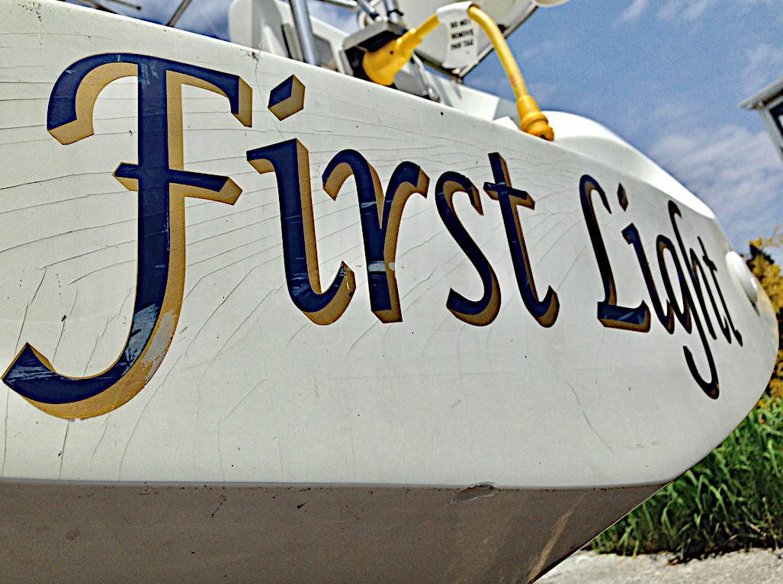

Unsightly gel coat stress cracks. Plus, the boat yard added a hull chip when hauling either by a small impact or over zealous pressure wash.

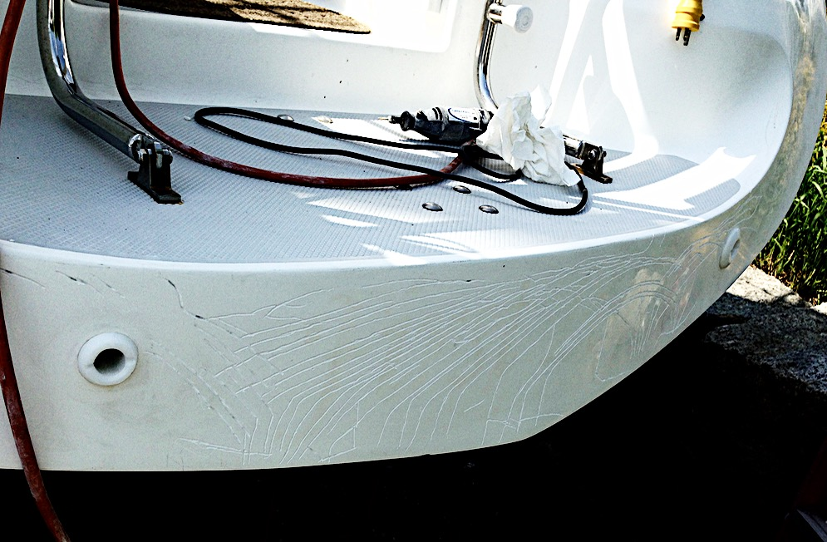

All the cracks were cut into with a small router bit on a Dremel tool. I routed pretty much through the gel coat thickness, but avoided going into the underlying fiberglass structure. This took several hours. Wear a face mask and safety goggles. It’s best to do on a windy day as it blows the dust away. Take your time. Wipe the area with acetone to insure wax is removed as you start the project.

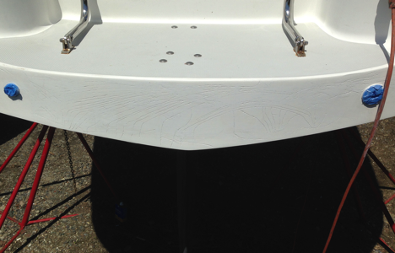

I mixed one once of Spectrum Catalina color matched gel coat (from I Boat; P/N F553521k, about $45 for a two ounce jar). I applied with a plastic spatula. The gel coat will shrink when it cures, so two or three applications might be necessary. The above picture was taken after the 1st coat was sanded. Sand with 80 grit paper on a sanding block until the surface is level and add the second coat and sand again. Select a good quality sand paper (like 3M) to avoid a product that “loads up.” If depressions are still present after the second coat, add a 3rd coat. You want the uncured gel coat thickness to be slightly elevated over the original surface. The gel coat has a working life of only tem minutes or so and may take 2-3 hours to cure at 75 degrees. Wait until it’s cured prior to sanding. Follow the mixing instructions from Spectrum; 10-12 catlyst drops per ounce of gel coat paste..

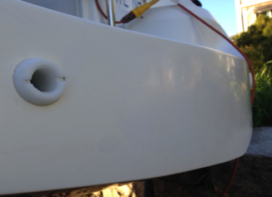

After the surface is relatively smooth and crevices completely filled, sand with progressively finer grit paper until you get to 600 grit or better- at which time, you should wet sand (by hand). Always use a sanding block and never get too aggressive. For grits finer than 600, you will be restoring a shine to the gel coat.

For the chipped area, I taped the chip parimiter and filled with gel coat, applying a thickness greater than the chip’s depth and then removed the tape and sanded it flush to the surrounding surface.