Replacing Large Portlights
- Take a sharp knife and cut the silicone caulk seal between the acrylic lens and the fiberglass. Start at one corner and work toward the middle of the port. I worked from both the inside and the outside of the boat. I eventually figured out that if I focused on cutting free the aft side of the portlight, I could cut and continually apply pressure to this end and it would help to break the silicone caulk bond as I worked forward. The first lens that I removed took about 2 hours of constant cutting. The second took about 45 minutes. You learn as you go.
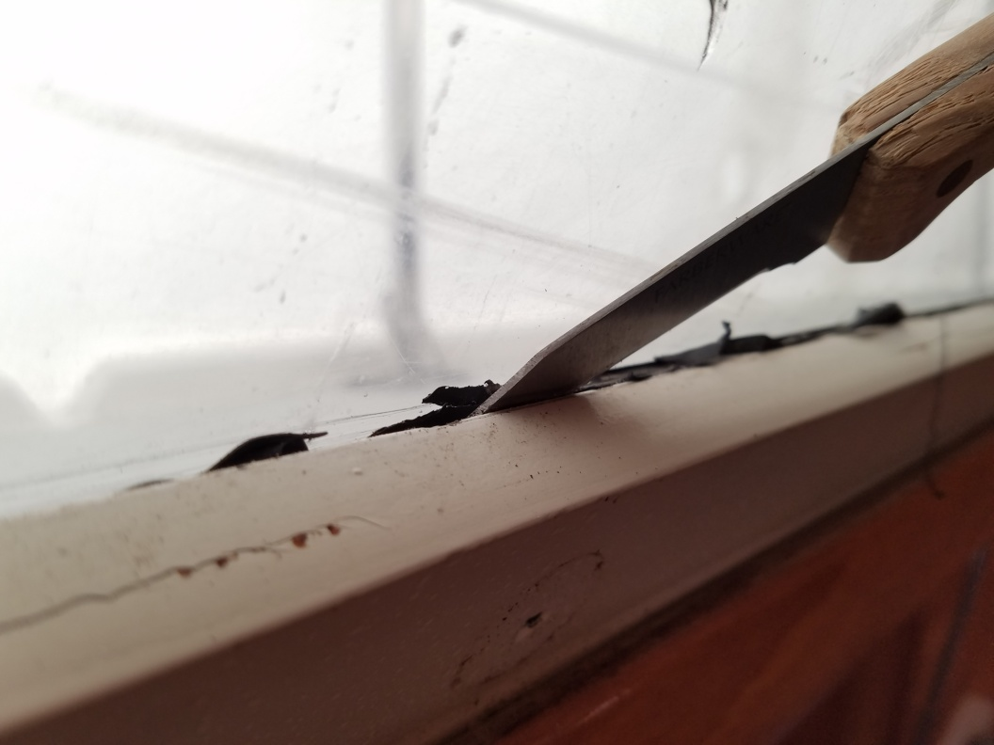
Figure 1: Cutting the silicone sealant between the fiberglass and acrylic portlight from inside the cabin.

- Once you have cut away the acrylic portlight, you have a lot of silicone caulk to remove from the fiberglass seat.
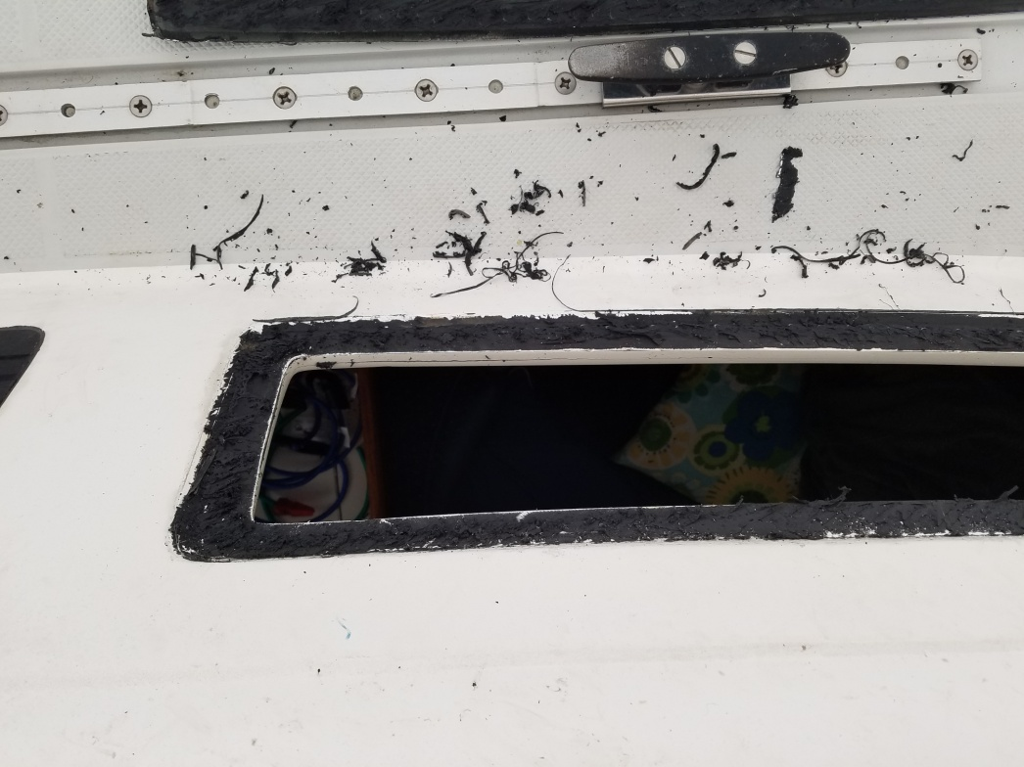
Figure 2: After the old portlight is removed, there is a significant amount of black sealant to be removed.
- I used a product called McKanica Silicone Caulk remover to help remove the caulk. It comes in a 3oz tube, and it took 1.5 tubes to remove two acrylic lenses. I spread the caulk remover on like butter and let it set for 2 hours. I then used a combination of a razor blade scraper and a metal putty knife, and the caulk came off easily in large chunks.
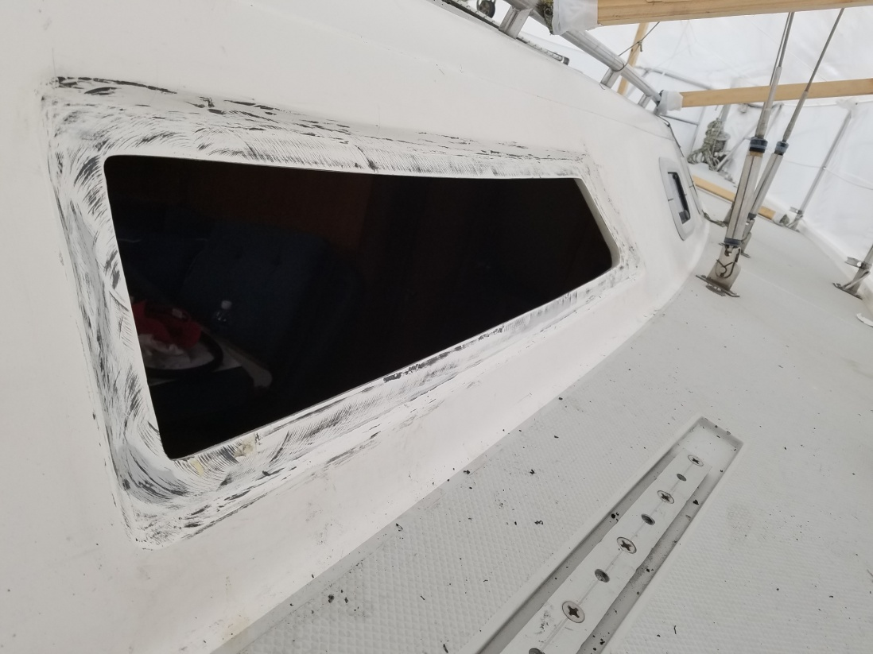
Figure 3: After the old sealant has been removed.
- I finished the removal with 120 grit sandpaper and cleaned with isopropyl alcohol.
- I took the old portlights to a local acrylic supplier where they matched the material (0.22” Acrylic 2064 Gray) and cut to the exact size of the originals, including the bevels. Each lens cost $125 cut. By the way, I got a quote from the Catalina factory for these acrylic panels, and the cost was exactly the same. So I did save maybe $15 or so in shipping costs by have a local supplier cut the portlights, but you could also get them from the factory for about the same price, FYI.
- To install the new portlights, I used a combination of 3M VHB double-sided adhesive tape and Dow Corning 795 silicone sealant ($15 per 10oz tube – I used maybe 2oz). The adhesive tape is the “new”’ way of bonding the lens to the boat, and the silicone sealant is put around the outside to keep the water out. It is a much simpler and cleaner way of doing the job, and by all accounts yields a much stronger bond. The tape part number is 3M Scotch 5952 VHB Tape, 1in x 15ft. I bought two rolls ($24 ea) and had plenty left over. Apply the tape on the fiberglass inset side, making sure there are no gaps between pieces and cutting the tape with a razor blade to match the shape of the lens and the opening.
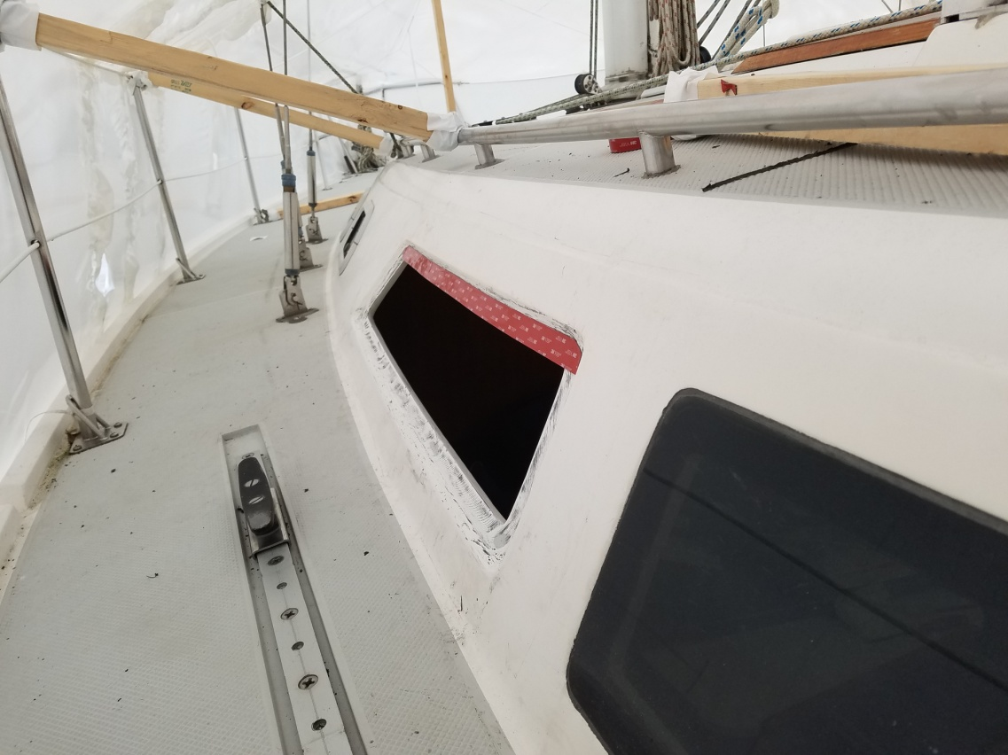
Figure 4: One strip of 3M tape has been applied. The tape needs to go all around the opening and cut to fit exactly.
- Understand that this tape is tenacious. This is not your typical double-sided foam tape. Once you pull the backing off and press the acrylic portlight into place, there is no going back or adjusting. When I placed each portlight, I carefully lined up the top edge first, slowly laid the lens in place downward from there, and applied pressure all the way around. The bond does not feel totally secure at first, but this tape takes 48 hours or so to fully adhere. When I came back a few days after first installing the new acrylics, I don’t think I could have kicked them out of place if I wanted to.
- Once the new portlights were in place, I applied masking tape to the cabin trunk around the outside of the lenses in preparation for the silicone sealant application. You only need to apply the sealant to the outside joint, and the masking tape should exactly follow the contour of the new panel. The gap I needed to fill between the fiberglass and the lens was obvious, but it works out to be about ¼” bead of sealant.
- I gooped the silicone into the portlight/cabin joint with a caulk gun, and followed with my finger. I immediately pulled the masking tape up and let the sealant set.
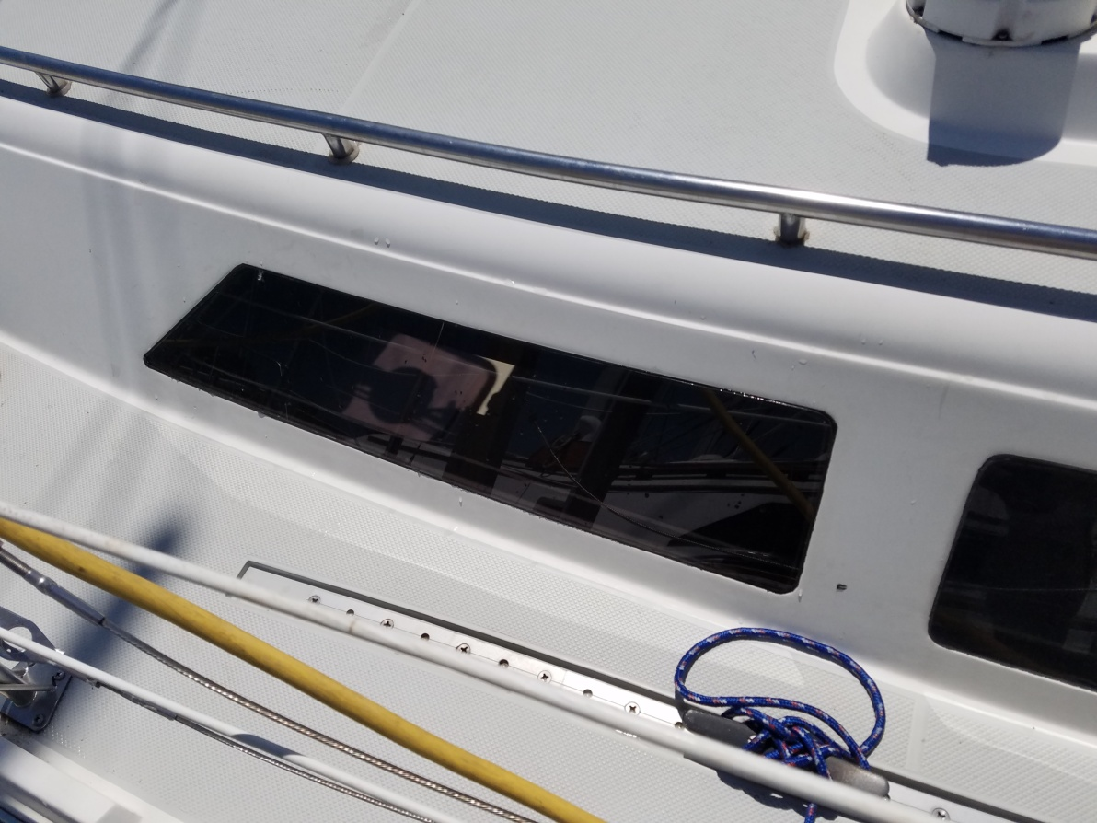
Figure 5: New acrylic port in place.
I am thrilled with the end result. The portlights look perfect and there are no leaks. They make the remaining two original large ports look old and scratched by comparison, so I may end up replacing those next year just to match. The cost for all of the materials involved, including the new acrylic, tape, sealant, and caulk remover came out to about $175 per portlight. If you’re handy with a jig saw and router, you might be able to reduce the cost by fabricating your own lenses, but for me it was worth the expense to have professionals cut the acrylic.

