To: dupin.catalina30@yahoo.com

From: Paul Keyser

West Newbury, MA

Subject: Replacement of Keel Stub on my 1986 Catalina 30, Morning Star

Mike-

I read the latest issue of Mainsheet and noticed a request for tech articles. Here is one that might be of interest.

We purchased Morning Star in 1993. It was a lightly used 1986 C30 with only 23 hours on the engine. She provided great joy to a family of 3 children and the family dogs for the many years we owned her. Like most all boats, she came from the factory with her bilge pump held in place by mounting screws in the bilge floor (keel stub). Over the years, water migrated into this area and a crack developed in the top fiberglass layer adjacent one of the keel bolts. I drilled a small core sample from the area and sure enough, found deteriorated wood below the fiberglass. I concluded that I would take on the project of replacing the keel stub over during the winter storage.

The diagram below details the Catalina keel stub area and contains notes on how to repair it..

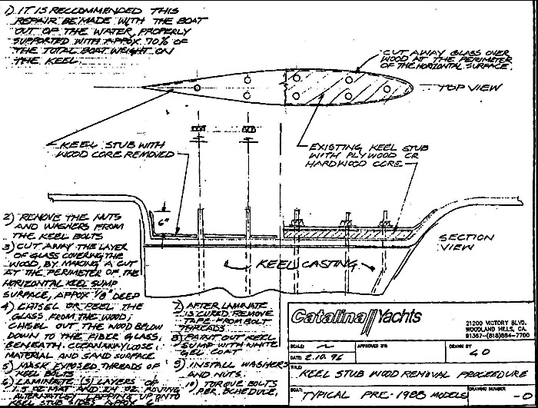

Note that the keel stub replacement must be performed with the boat on the hard.

First, I removed the bulkhead seat to open up access to the forward bilge area to the mast compression block. Next I removed all the nuts and washers on the keel bolts. Then, I sat with chisel and hammer, starting in the rotted section first. To my surprise, I found water had penetrated only about a 6-8” length of the keel stub involving two keel bolts. The smart thing would have been to replace just this section, but I decided to replace the entire stub. (A Dremmel reciprocating saw would have been the perfect tool to perform a section repair)

The keel stub is comprised of a ½ inch later of Marine Plywood fiber glassed to the bilge. A second ½ inch layer of Marine Plywood is laid on top of the first layer and this too is glassed in place. The keel is bonded to the hull and held in place with its many bolts passing through the fiberglass hull and wood keel stub. In my situation, only the top layer of plywood had been penetrated by water, so I limited my work to removing just that. Per the diagram, Catalina appears to have utilized a different keel stub designs (hardwood, plywood etc.). One could replace the rotted wood with a thick glass fiberboard similar to that used in printed circuit boards and that would certainly eliminate future rot, but I found the material to be cost prohibitive.

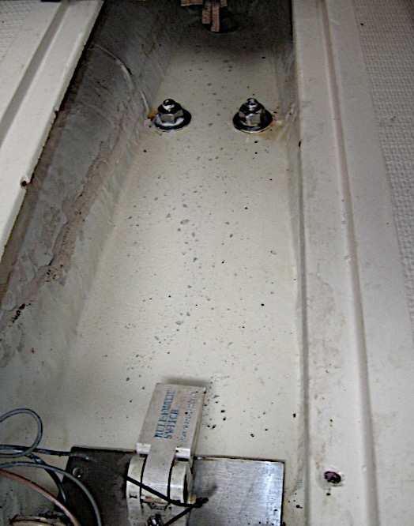

I chiseled along the hull interior to break the fiberglass layer holding the plywood in place. Then I chiseled horizontally to remove the 1st layer of plywood. It separated cleanly from the lower layer. As I removed material from around the keel bolts. I found that our boat had zero corrosion in the stainless steel. When seawater migrates into this area, it can cause keel bolt corrosion that is undetectable without removing keel stub material. Catalina had done a great job bedding the bolts and preventing this. None of the bolts exhibited any corrosion. When I had chiseled up to the mast compression block, I took another core sample to see if water had penetrated the compression block and was pleasantly surprised to find that the block was solid. Water migration into the compression block is a potential design weakness in the C30 and can lead to cabin roof distortion and loose stays as the mast compression support deteriorates.

**Fill the plywood/hull gap with epoxy prior to applying fiberglass matting**

**Run Fiberglass up the sides of the bilge**

The opposite end of the keel stub beneath the engine proved the biggest challenge. There was little clearance between the keel nuts and the M25 Engine oil pan, plus I could only rotate the nuts about 1/8 of a turn before the wrench handle contacted the sides of the bilge. Lastly, I had to locate a chisel with a very long handle. This part of the job involved contorted agony. It might have been made easier if I had taken the time to raise the engine.

After removal of the entire top plywood layer, I laid poster board in the keel area to create a template and also locate the keel bolts. From this, I cut a new plywood layer from ¾” marine plywood (to provide a additional keel support, but it also reduced the depth of the bilge by ¼”). I found that I had to cut the length of the replacement keel stub in half so I could properly maneuver the stern portion beneath the engine. (Again, with engine raised, this probably could have been avoided). I coated the plywood with epoxy to minimize future water penetration (especially in the keel bolt holes). After the epoxy sealant cured, I placed the new keel stub in the bilge and applied several layers of woven fiberglass over it and epoxied it in place. I ran the layers ran up the side of bilge.

I used electrical tape on the keel bolts to prevent epoxy from gumming up the threads and removed this prior to the epoxy fully curing. I squeegeed the epoxy-glass layers as best I could to minimize air bubbles. After the laminate cured, I used 3M 5200 as a sealant between the keel bolts and plywood. The bolt holes were about 1/8” larger than the bolt diameters and the sealant filled this gap. I then painted the bilge with Petite urethane bilge paint. Lastly, I installed and torqued the nuts to 105 ft. lbs. I had to guess at the torque on the two aft bolts, as a torque wrench would not fit in the space.

Total job time was about 30 hours. Again, in hindsight, I could have replaced just the damaged keel stub area with a fraction of the effort.